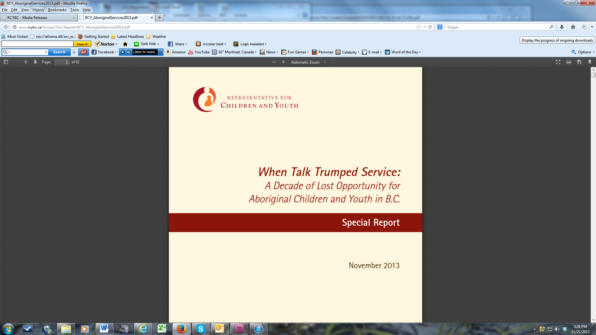**Job Profile**

|  |  |
| --- | --- |
| **TITLE: Investigator** | **CLASSIFICATION: Band 2** |
| **POSITION NUMBER: Multiple** | **SUPERVISOR TITLE: Manager, Investigations, Reviews and Investigations** |

**JOB OVERVIEW**

The Representative for Children and Youth (RCY), an independent officer of the B.C. Legislature, works to influence positive change to B.C.’s child-, youth- and young adult-serving system. The Representative’s Office provides advocacy support to people dealing with the child and youth service system and advocates directly on behalf of children, youth and young adults, monitors and reviews government services to children and youth and reviews and investigates selected deaths and critical injuries of children and youth who are receiving services.

Two interconnected priorities for RCY are to: 1) identify, recommend and advocate for ways to reduce the number of First Nations, Métis, Inuit and urban Indigenous children and youth in government care, and to improve child welfare and other designated services to those Indigenous children and families who come into contact with the Ministry of Children and Family Development and/or Delegated Aboriginal Agencies; and 2) meaningfully, ethically and sustainably engage with children, youth, young adults and the community members who care about and for them to enhance RCY’s understanding about their lived and living experience, especially with systems of care.

To support these priorities, RCY is committed to becoming a more culturally aware and agile organization, integrating Indigenous ways of knowing and being into our daily practice, and ensuring that our work highlights concerns with and opportunities to improve the experience of and outcomes for First Nations, Métis, Inuit and urban Indigenous children and youth in need of services. RCY supports all staff to develop a critical understanding of the history of First Nations, Métis, Inuit and urban Indigenous Peoples within Canada and the impact of colonization on the contemporary experience of children, youth, families and communities and on current systems, structures and politics. Meaningful relationships with Indigenous leaders, young people, organizations and communities are of vital importance to RCY.

In addition, RCY is committed to centring and amplifying the voices and lived and living experience of children, youth and young adults who are or have engaged with B.C.’s child, youth and family serving systems.

The Investigator reports to the Manager, Investigations.

The Investigator plans, develops, supports, and leads case reviews, special reports, and complex investigations into injuries or deaths of children receiving reviewable services. The Investigator identifies service gaps and key areas where improvement to services and programs for children and youth is required and provides recommendations regarding those improvements. The Investigator writes investigative reports, case review reports, and special reports on child deaths and critical injuries. They may be asked to lead or support a variety of projects. Investigators work closely with Investigations Analysts and may assist with their aggregate projects as assigned. Excellent written and verbal communication skills, independent and teamwork skills, and time and project management skills are essential to this position.

**ACCOUNTABILITIES**

* Conducting and supporting file reviews, investigations, and special reports of child injuries and deaths through interviewing, information gathering, and other investigative techniques and strategies. This process may be individually led or team-based
* Employing a range of methodologies, conducts detailed research and analysis of issues resulting from reviews and investigations.
* Meets required timelines for reviews, research and project-based work
* Creates briefing documents for RCY management using various data sources
* Develops, implements and monitors detailed project plans, including but not limited to investigative plans. Creating and implementing project plans may include liaising with stakeholders, academic researchers, Indigenous knowledge keepers, government staff, and other internal agencies and staff
* Conducts formal investigative interviews, a process which includes managing witnesses, preparing interview plans, taking evidence under oath, and analyzing the information gathered
* Evaluates and determines the validity of investigative data, analyzes results, and provides detailed case reports, including findings and recommendations
* Identifies opportunities to significantly improve programs and services to children and youth including identifying service gaps, and provides recommendations for the formulation of prevention strategies
* Works in close partnership with others including: external researchers and research contractors, academics, other government analysts, and RCY colleagues
* Develops networks, builds team orientation, gathers information, and develops and implements best practices
* Writes comprehensive investigative reports, reviews, aggregate reports, annual and special reports on child deaths and critical injuries
* Participates in cross-RCY program area projects and activities as needed.
* Performs various related duties as assigned.

**JOB REQUIREMENTS**

**Education and Related Experience**

A Bachelor’s degree in social sciences or a related discipline (e.g. Health Sciences, Child and Youth Care, Social Work, Psychology, Criminology or Law) is required. An equivalent combination of education and experience may be considered if the degree is not in a related discipline.

A minimum of two years’ work experience conducting complex investigations and reviews, which includes:

* Understanding investigative principles
* Organizing, analyzing, and interpreting key events and contributing factors gleaned from review of complex materials
* Gathering evidence
* Conducting formal interviews
* Conducting research as well as collecting and managing data
* Developing findings and conclusions based on evidence gathered
* Managing multiple, complex projects with tight deadlines
* Writing clear, concise, and accurate evidence-based reports, briefing notes, presentations, and other materials that disseminate complex issues to a public audience that may include provincial government policy makers, service providers, community partners, and the general population.
* *Preference may be given to applicants with experience working with children and families who have received child welfare services, family services, guardianship services, child and youth special needs services, adoption services, youth justice services and/or child and youth mental health and substance use services*
* *Preference may be given to applicants with more, or more recent, investigative experience.*

**Knowledge**

* Thorough knowledge of the principles/techniques of investigation
* Knowledge of electronic information and case management systems
* Knowledge of prudent data collection and storage
* Demonstrated knowledge of social policy issues and the challenges in delivering public services in B.C.
* Experience working with children and families who have received child safety services, family services, guardianship services, child and youth special needs services, adoption services, youth justice services and/or child and youth mental health and substance use.
* A critical understanding of why social inequities exist, colonialism, and the ability to be reflexive as an investigator
* Knowledge of First Nations, Métis and Inuit peoples and child welfare issues within a decolonizing framework
* Knowledge of child and youth services related to child welfare, child and youth mental health and or substance use issues, youth justice, children and youth with special needs, Indigenous Services for children and youth, adoption services, education, social services and child development
* Knowledge of relevant law, policies, practices and issues related to oversight of child and youth serving systems
* An understands the principles of OCAP (<https://fnigc.ca/ocap>) and how these may apply to CID’s responsibilities and practice.

**Skills and Abilities**

* Ability to be part of a team and/or lead a team through all phases of the project management life cycle
* Demonstrated strength in conducting investigations and reviews
* Ability to network and form external and/or internal collaborative partnerships
* Ability to conduct literature reviews and/or jurisdictional comparisons
* Ability to work with speed, accuracy, attention to detail, and integrity
* Superior ability in writing clear and concise investigative documents that identify trends and include relevant theory
* Strength in oral presentations to a wide variety of audiences
* Skills in the area of policy analysis, project management, evidence-based research, and best practices regarding services and outcomes for children and youth
* Skill in the Microsoft Office suite including Word, Outlook, PowerPoint and Excel

Please note that applicants must be able to successfully meet RCY security screening requirements which include a criminal records check, and Criminal Records Review Act (CRRA) check.

**COMPETENCIES**

* **Indigenous-centered service approach** is a desire to serve Indigenous peoples, focusing one's efforts on understanding their interests in order to increase the quality of the service and produce better outcomes.
* **Cultural agility** is the ability to work respectfully, knowledgeably and effectively with Indigenous peoples.
* **Analytical Thinking** is the ability to comprehend a situation by breaking it down into its components and identifying key or underlying complex issues
* **Information Seeking** is driven by a desire to know more about things, people or issues. It implies going beyond the questions that are routine or required in the job.
* **Building Partnerships with Stakeholders** is the ability to build long-term or ongoing relationships with stakeholders (e.g. someone who shares an interest in what you are doing). This type of relationship is often quite deliberate and is typically focused on the way the relationship is conducted. Implicit in this competency is demonstrating a respect for and stating positive expectations of the stakeholder.
* **Listening, understanding and responding** - the desire and ability to understand and respond effectively to other people from diverse backgrounds.
* **Planning, Organizing and Coordinating** involves proactively planning, establishing priorities and allocating resources.
* **Teamwork and Cooperation** is the ability to work co-operatively within diverse teams, work groups and across the organization to achieve group and organizational goals. It includes the desire and ability to understand and respond effectively to other people from diverse backgrounds with diverse views.

**For more information on competencies, see:**

[**About Competencies - Province of British Columbia**](https://www2.gov.bc.ca/gov/content/careers-myhr/job-seekers/about-competencies?keyword=competencies)

[**Indigenous Relations Behavioural Competencies - Province of British Columbia**](https://www2.gov.bc.ca/gov/content/careers-myhr/job-seekers/about-competencies/indigenous-relations?keyword=indigenous&keyword=competencies)